ORACLE INSTALLATION
This is download link for Oracle 21c
Go to Google and paste the below ink
https://www.oracle.com/database/technologies/oracle21c-windows-downloads.html
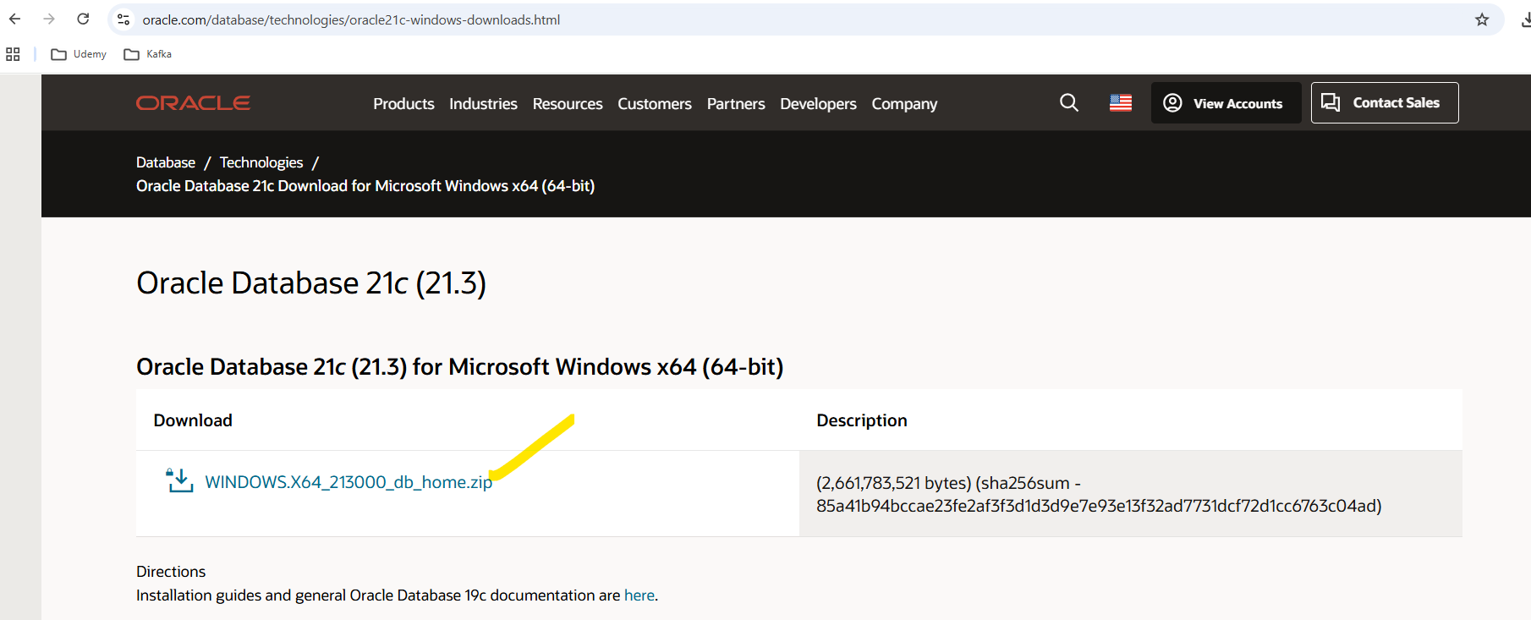
download the above zip file by using login credentials I am giving below please use
Oracle Site Login Details:
Uname: kkarthik739@gmail.com
password: *UCzL=~r"q#xN9t
After given this details Zip folder file will download into download folder
Note: After downloading, this zip folder should be moved to a separate folder on the C drive.
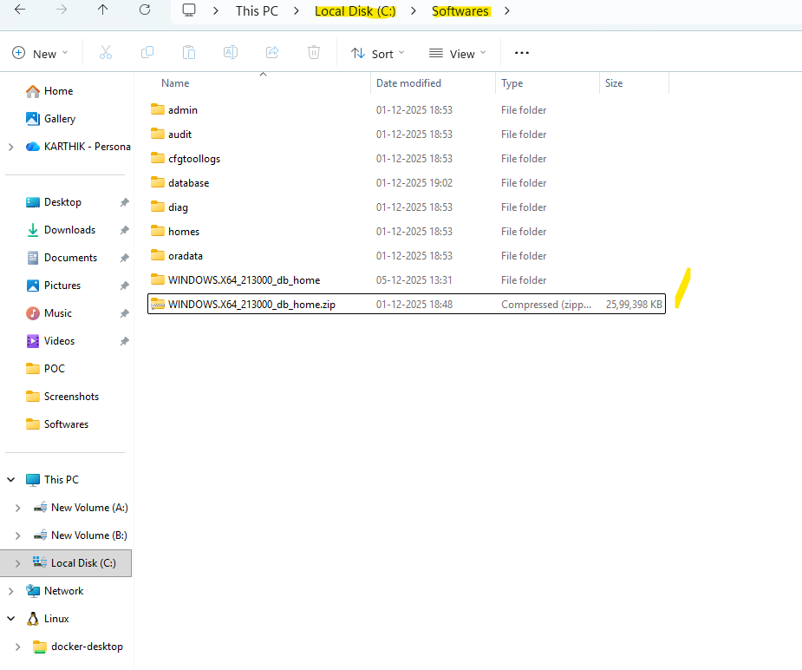
After moving the zip folder we should extract here only like below
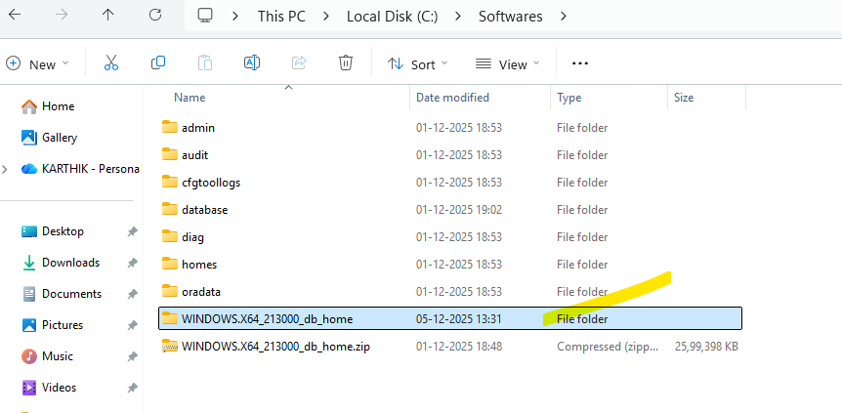
After Extracted this file zip symbol is gone like above after that we should open the extracted file and scroll down the file and select the setup.exe file
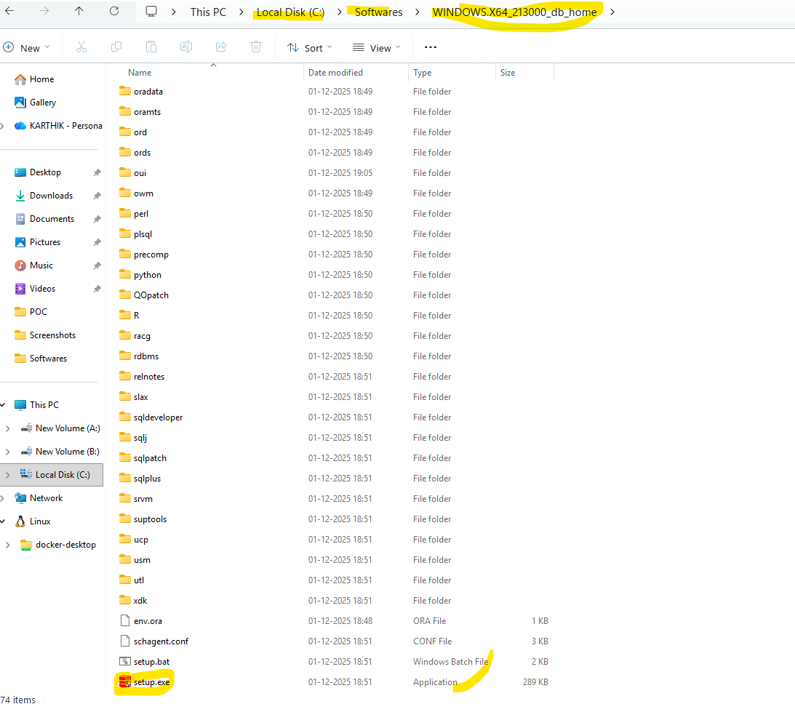
After clicking the exe file installation will be start like below
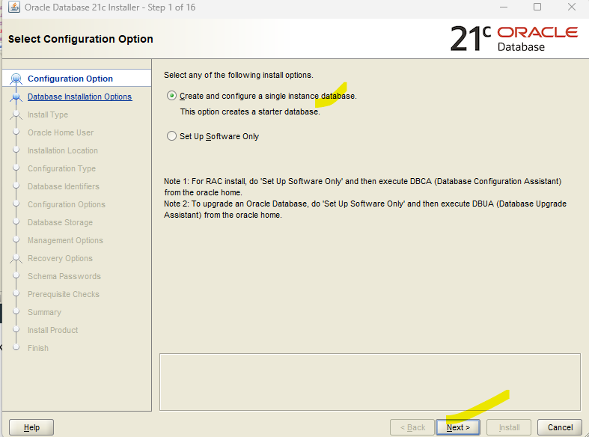
Choose create and configure and click next button

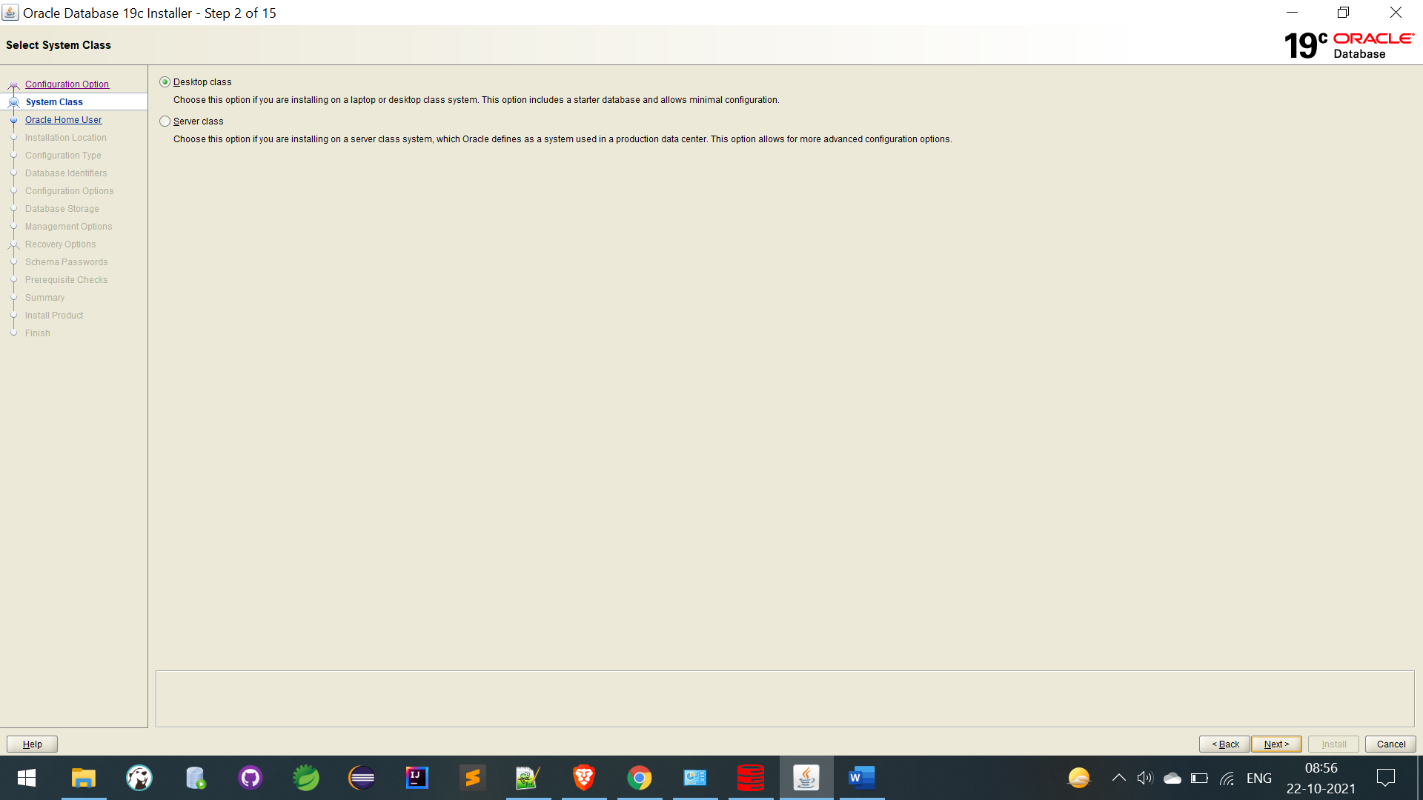
Next

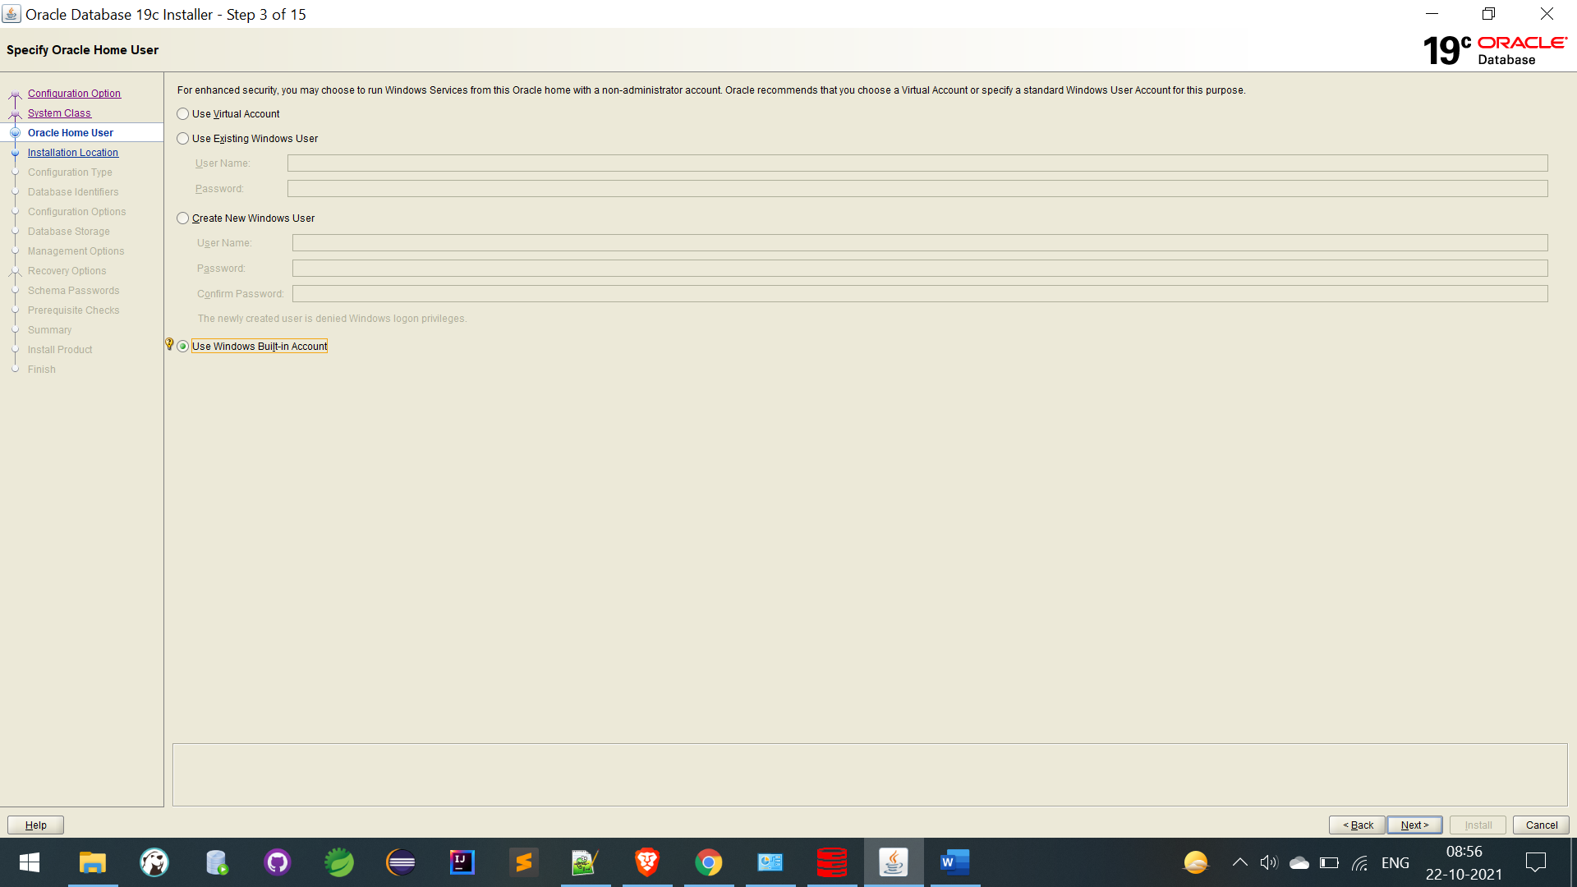
Next

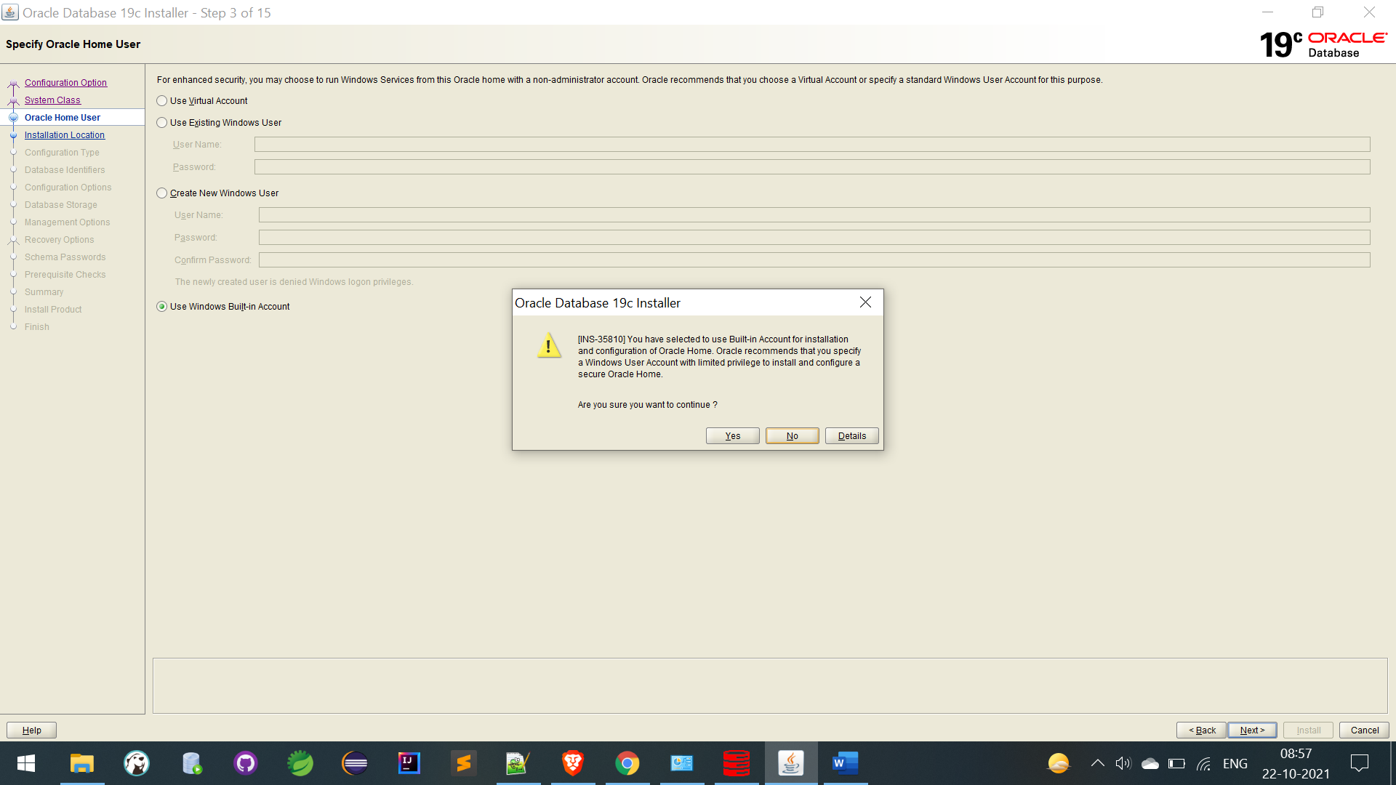

Click Yes above like

Select Global data base Edition name is: Orcl
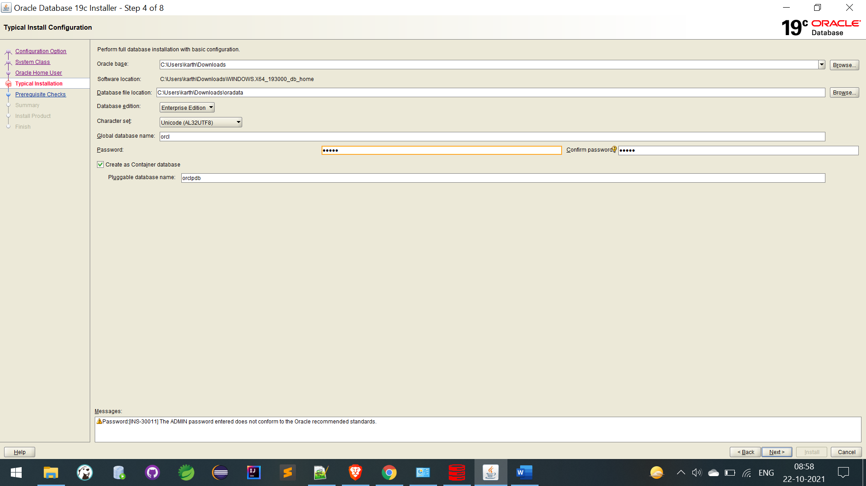
Password : tiger

Click on yes
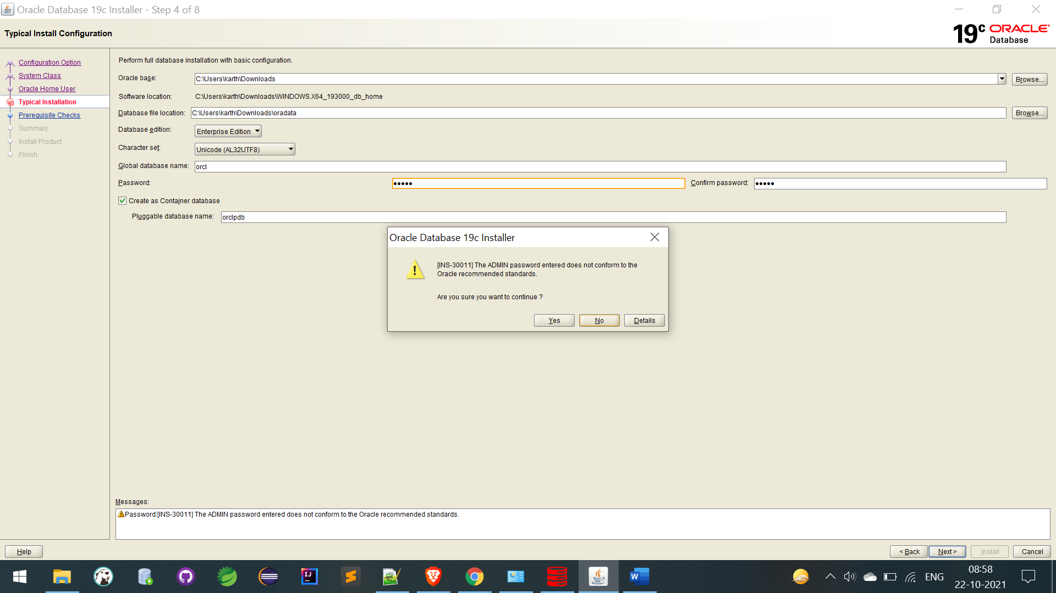

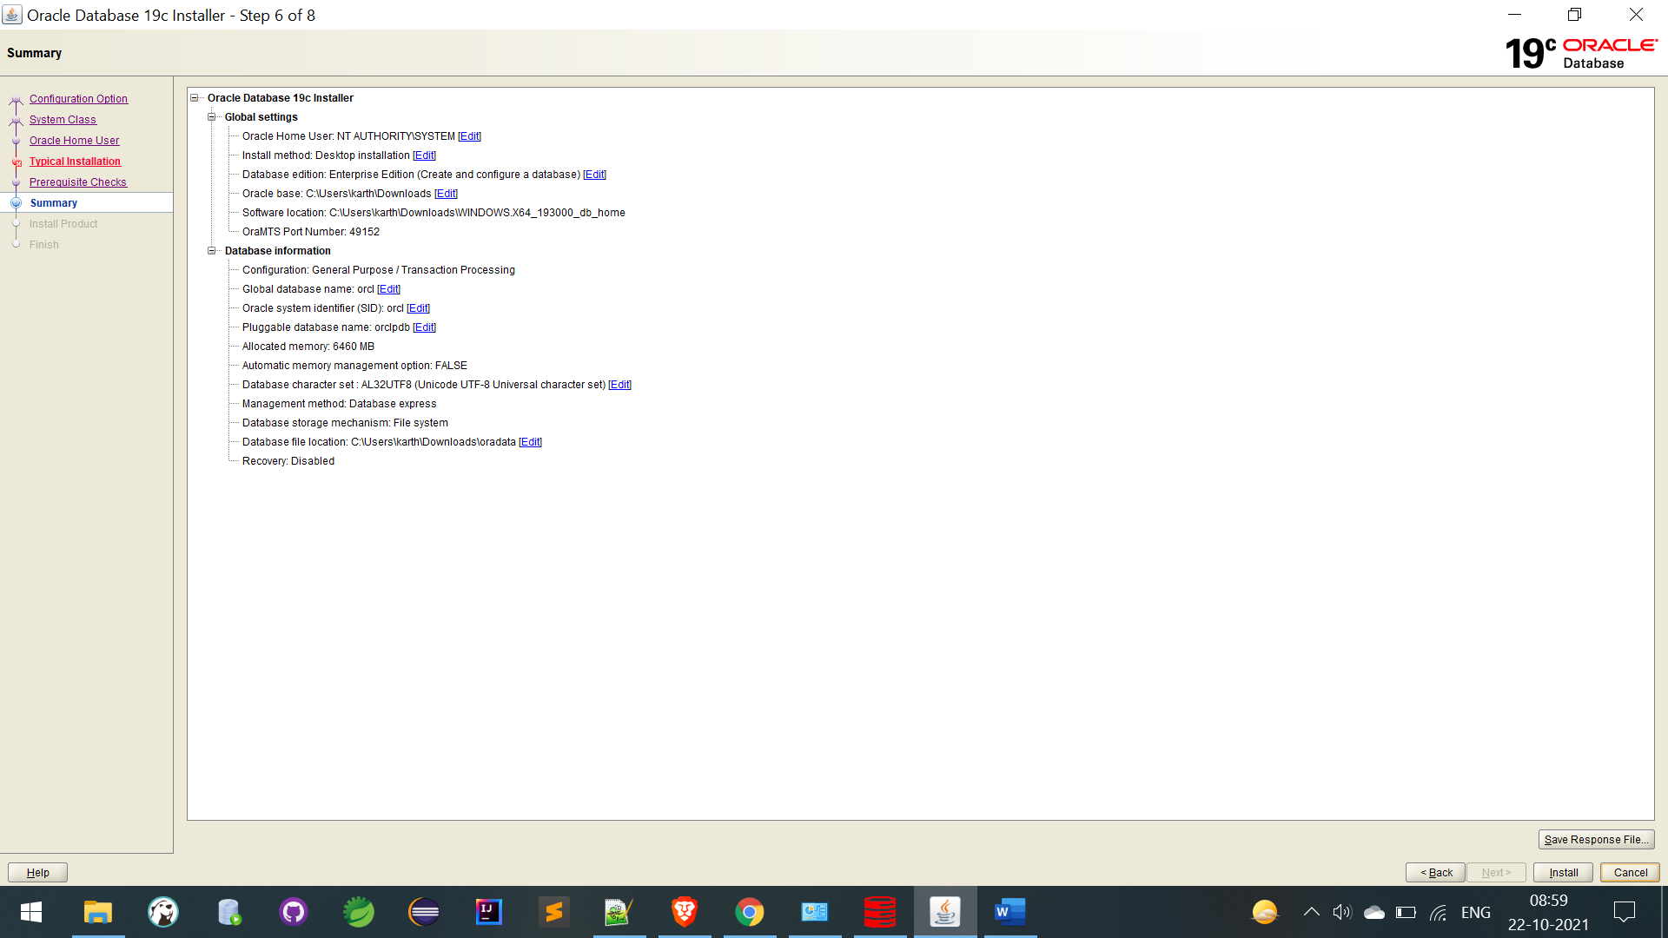
Click install button

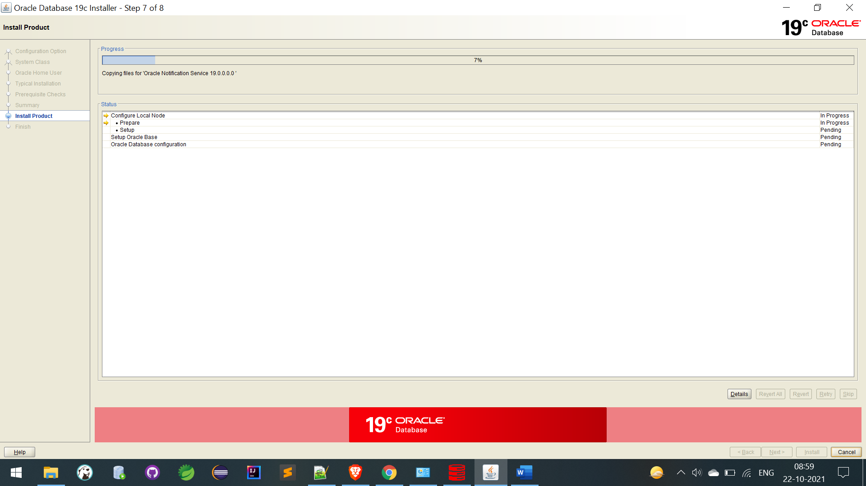
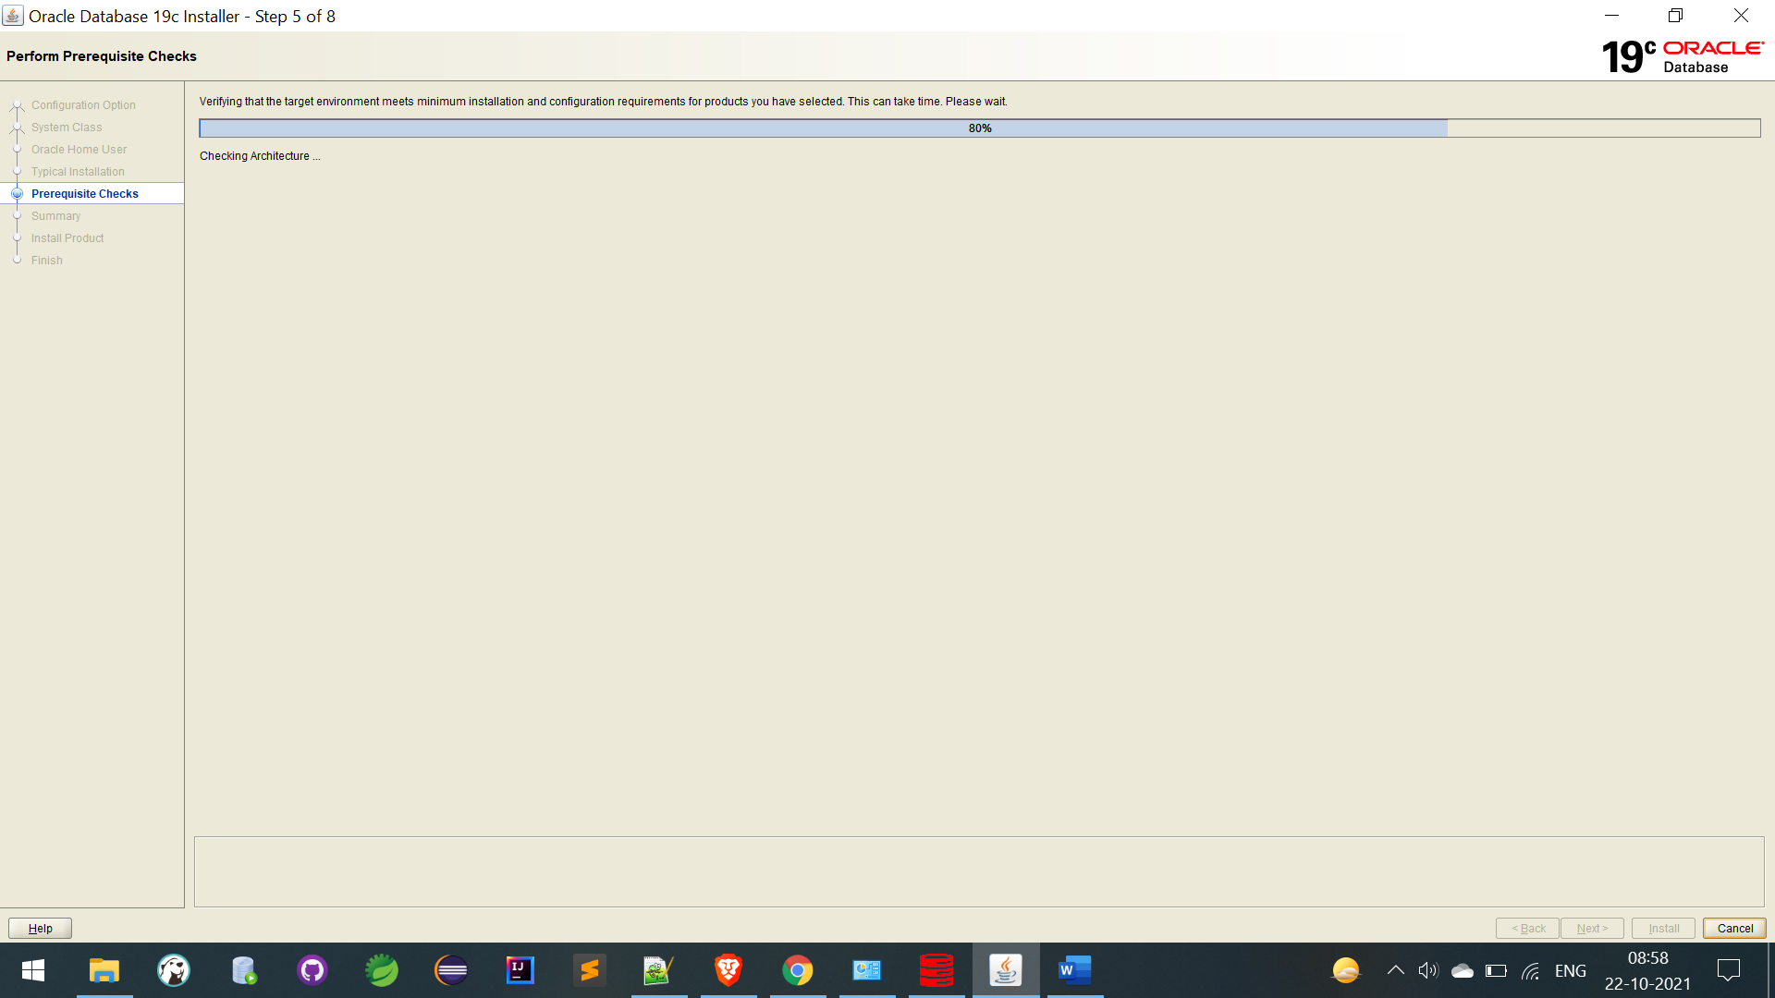

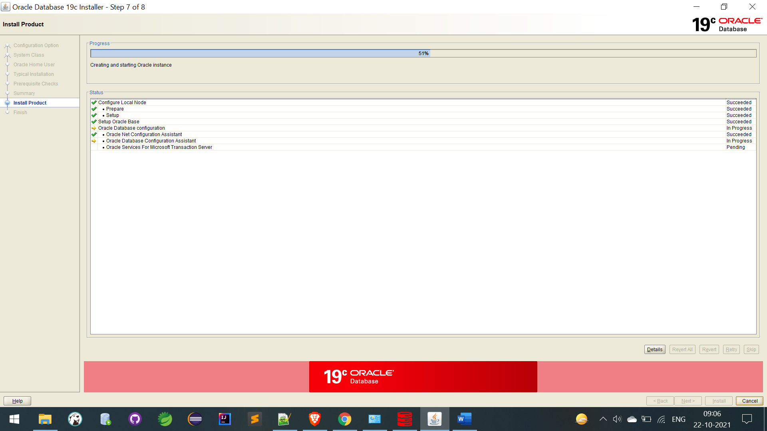

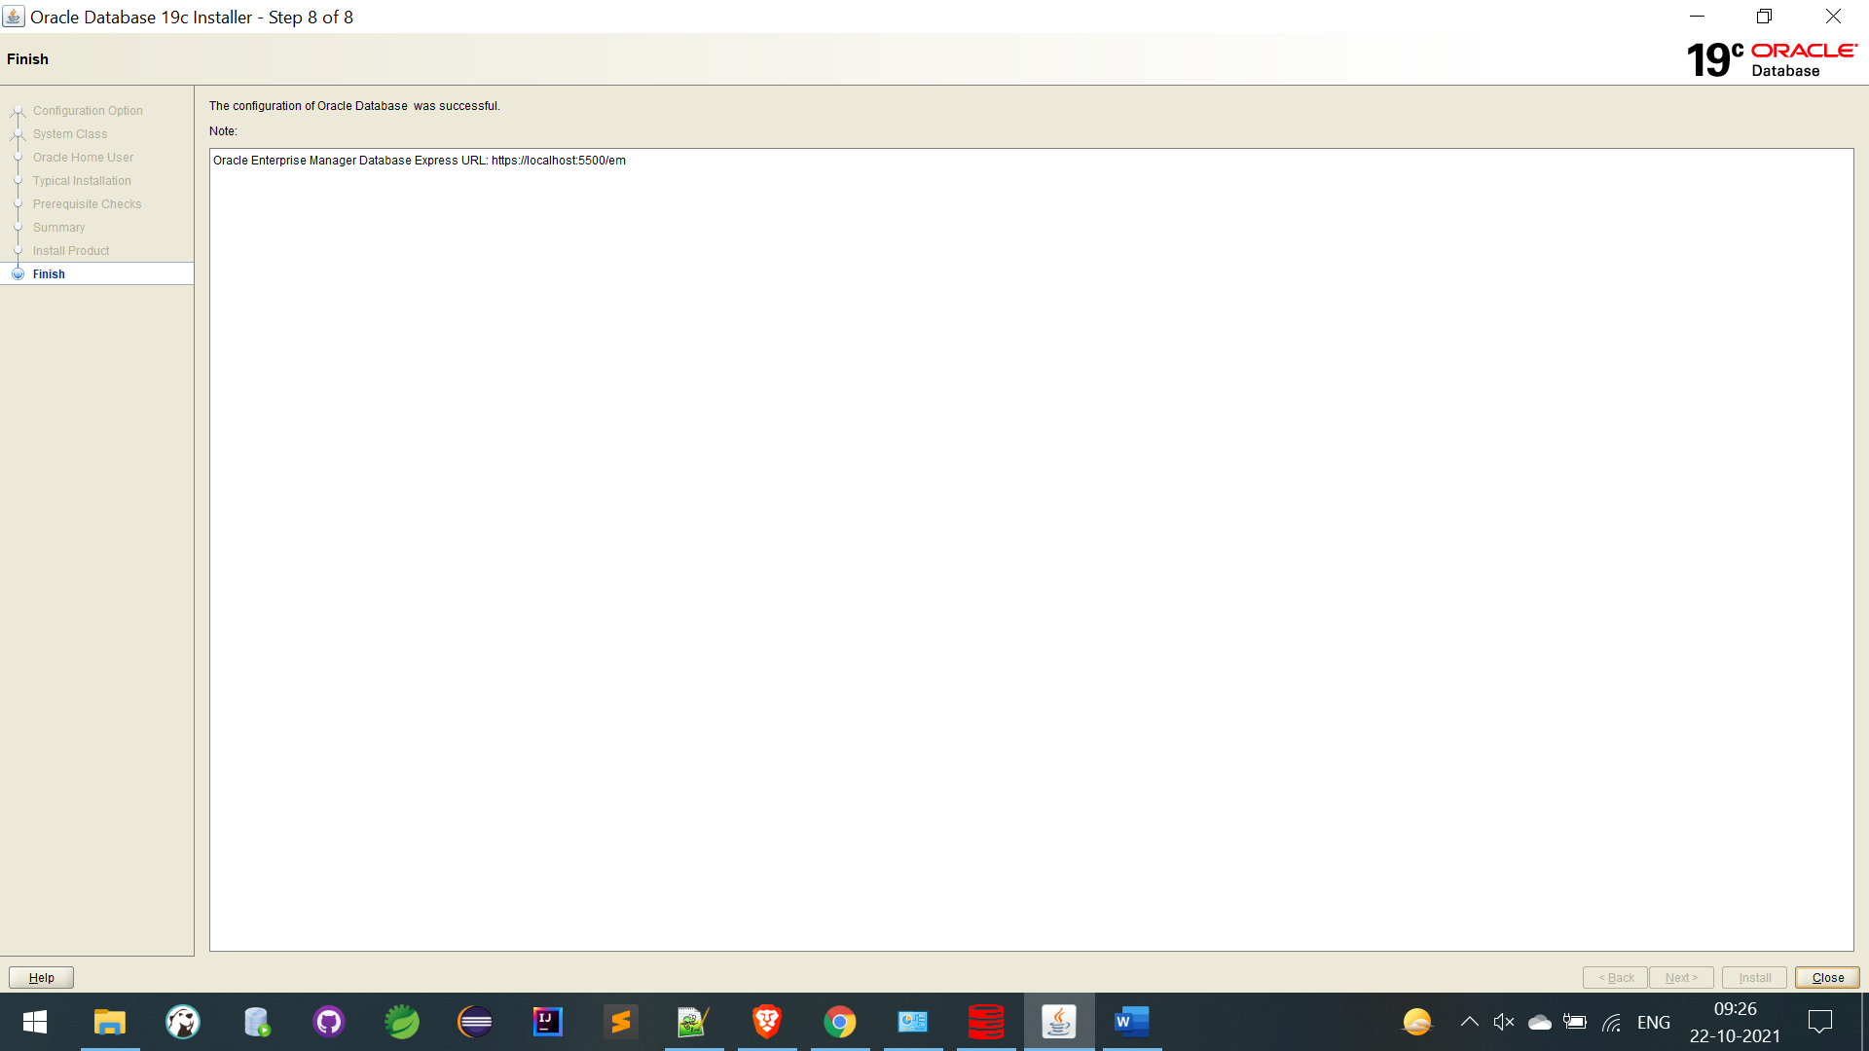
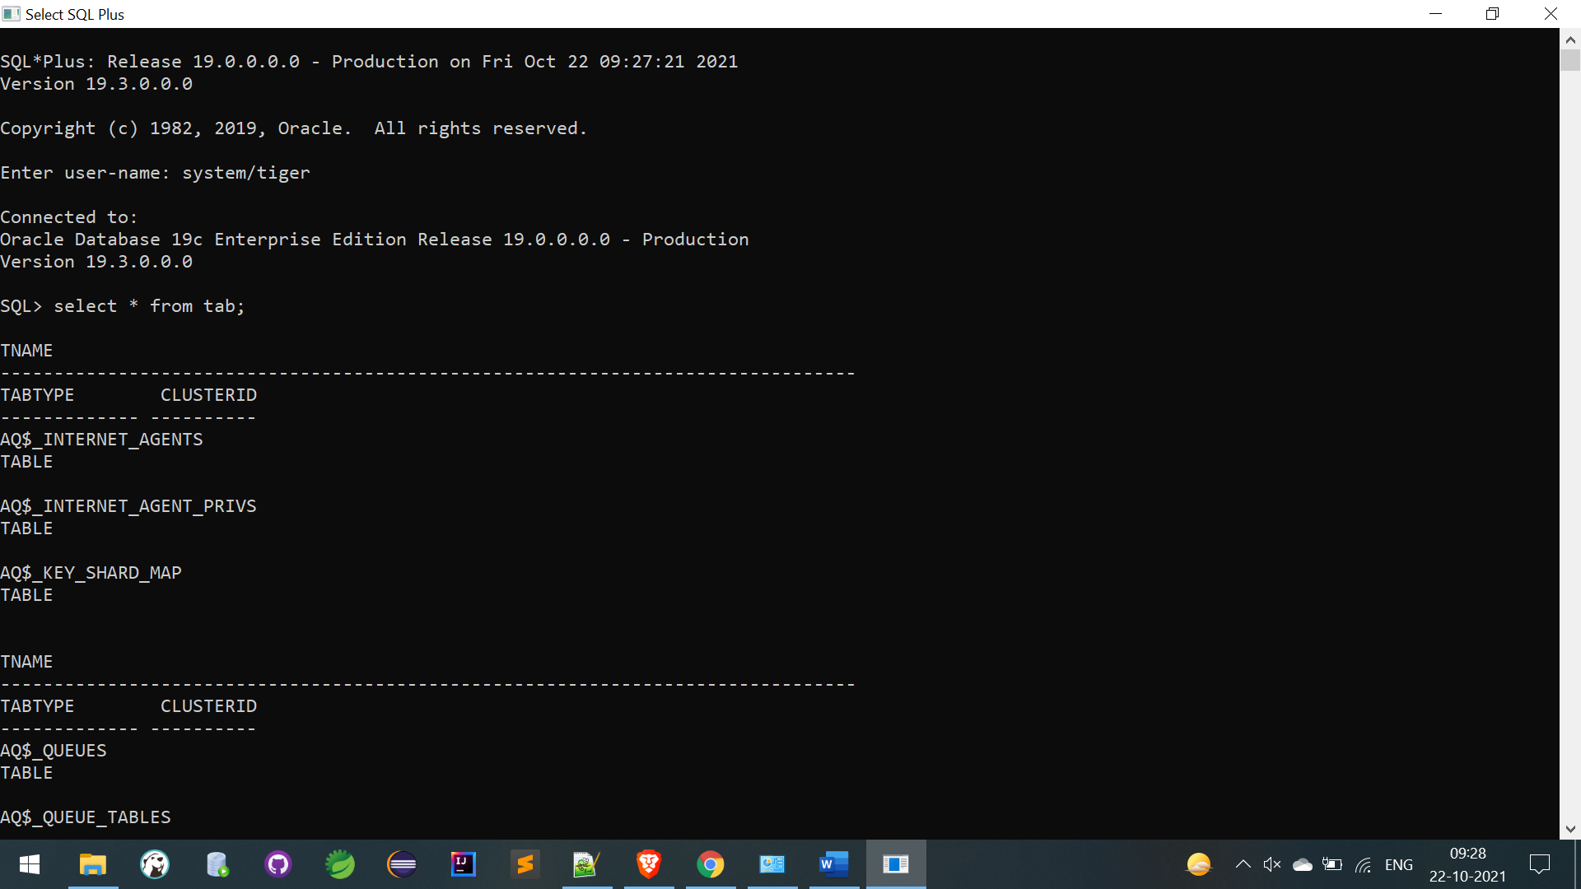

When I was started my db I am getting TNS Error:
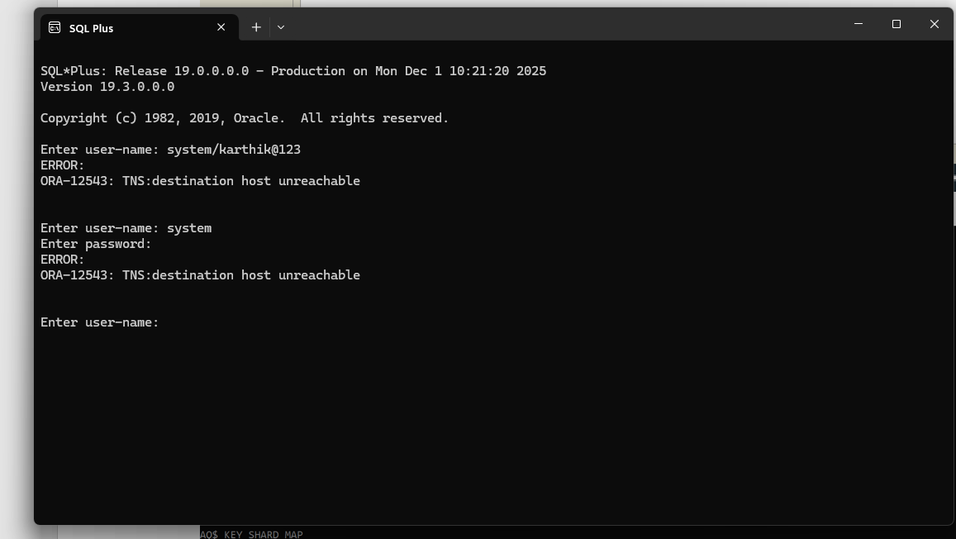
Solutions :
